Dang Bao Nghi Nguyen

COURSE: SOFTWARE DEVELOPMENT PROJECT

ASSIGNMENT 1

GIT REPOSITORY

2020



**CONTENTS**

**1. Procedure 3**

**1.1. Create the project 3**

**Git Repo 3**

**Git Commit 4**

**Git Branch 6**

**Back and forth previous version of Git 7**

1. **Procedure**
   1. **Create the project**

* **Git Repo**

First, we need to create a folder in any desire computer directories, next navigate to the folder that have been created and create some text file to demonstrate. In this case I will be creating a text file name **“NghiNguyen - Git Version Controll.txt”**.

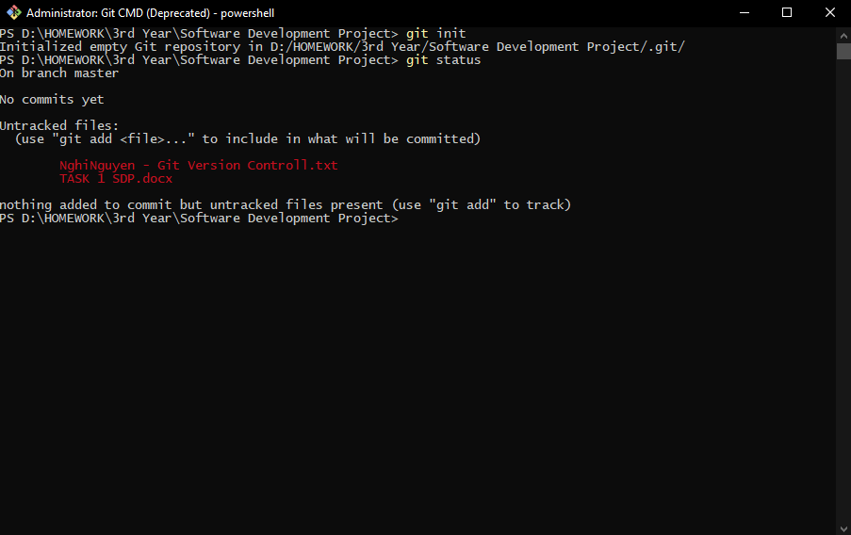Now that we have everything we need, open the **“GIT CMD (DEPRICATED)”**, navigate to the folder that contains the **“NghiNguyen - Git Version Controll.txt”** file, and use the command **“git init”**, something like this:

To know whether or not we are doing this correctly a **“.git”** folder will be created, meaning, we have successfully turned the folder into **“Git Repo”**, similar to this:

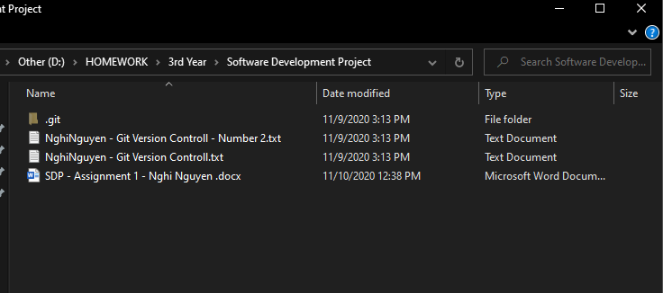

* **Git Commit**

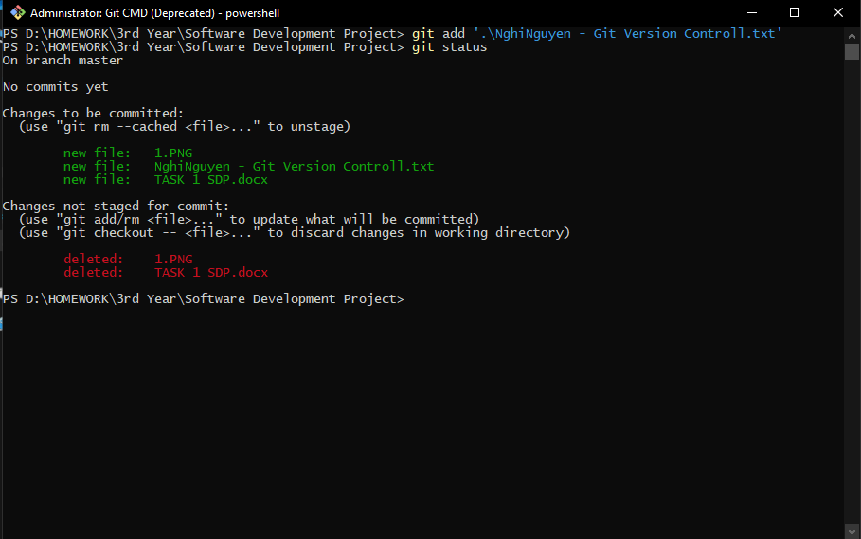Let us move on the part where we will **“ADD”** and **“COMMIT”** the file to the **“Git Repository”**. For adding the file into the **Git Repository**, we use **git add [name of the file].**

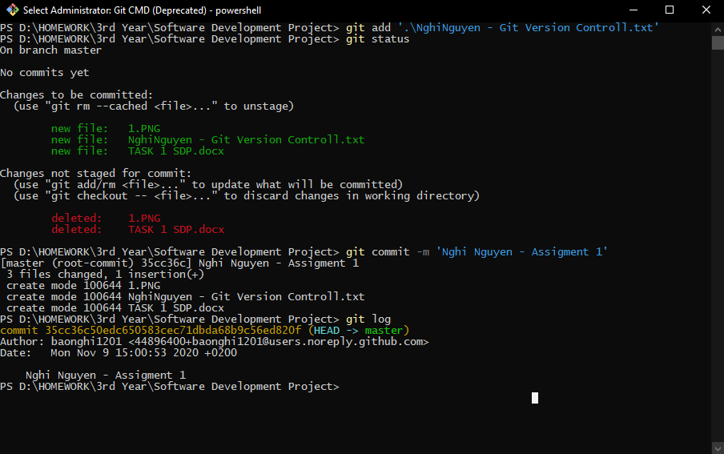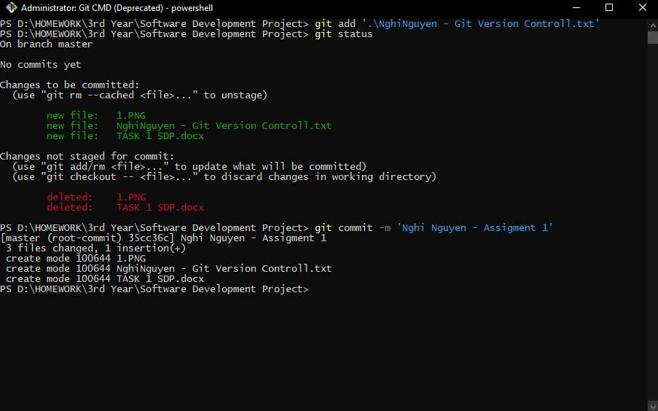Committing the file, we will use **git commit -m ‘[any name]’.**

* **Git Branch**

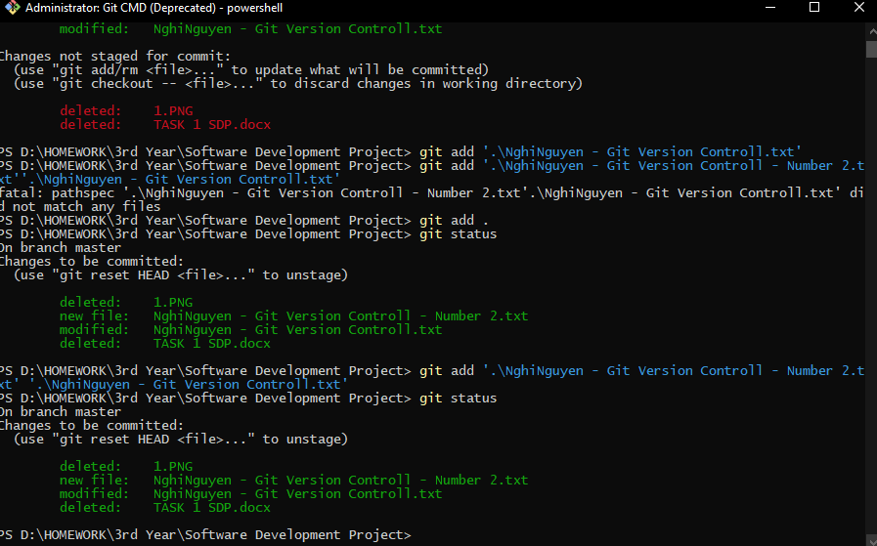Like trees, **Git Repository** also have branches, let us try to create another branch by creating another file or modify the file in order to see the difference. Looking at the result, we can clear see the file existing file has been modified, in addition a new file was created at the same time, were also put into **Git commit**.



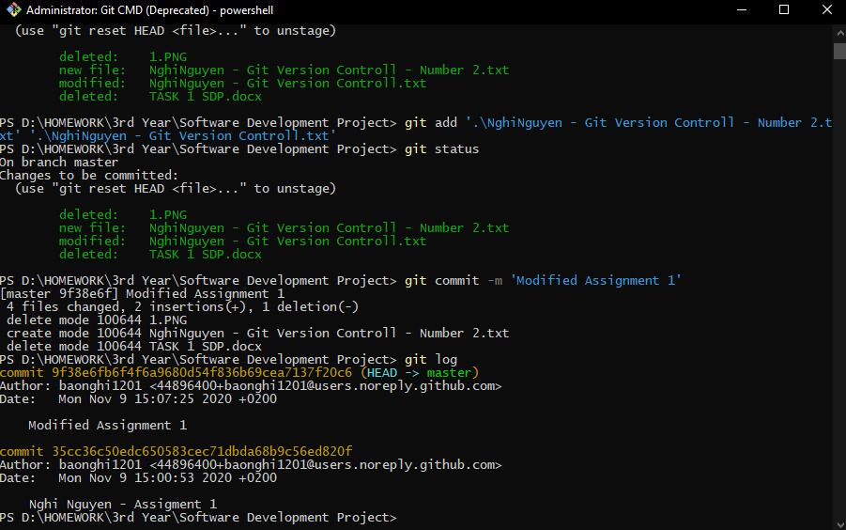

* **Back and forth previous version of Git**

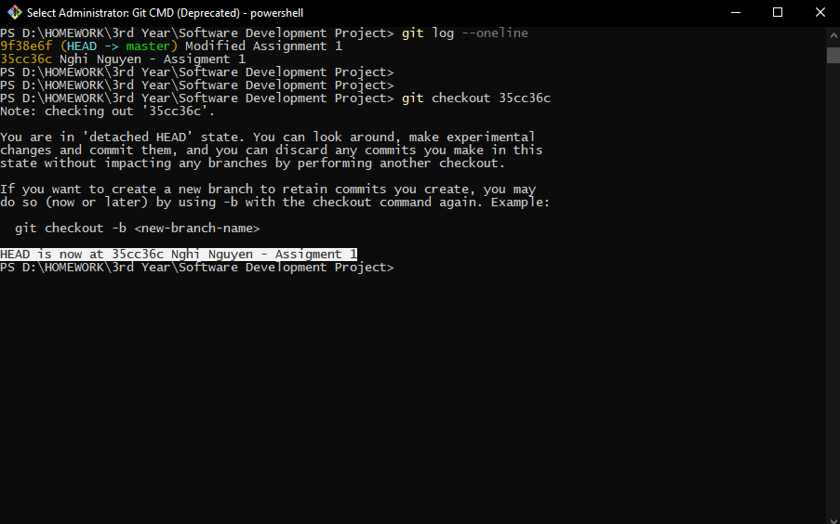Now, let us check the **Git branch** by using command **“git log –oneline”**, from here we can clearly see that we have successfully split the git repository into two branches that has been serialized into **9f38e6f** and **35cc36c.**

Knowing two another branch is currently exists on the git repository, let us try to switch back and forward by using **git checkout [branch number]** to do so.

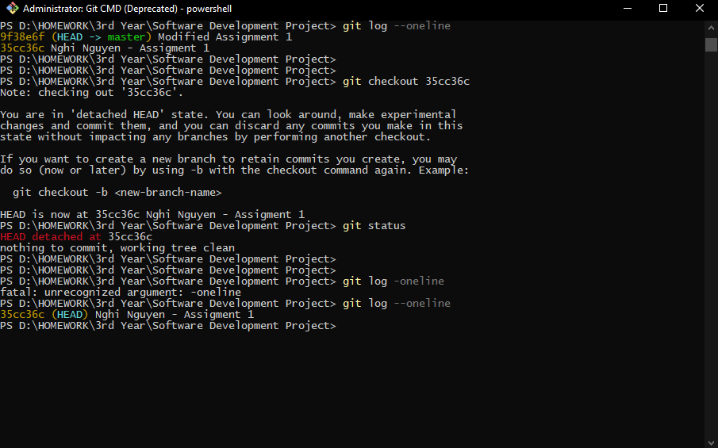



This is the previous file from the **git repository** after we detach and go back to the previous version:

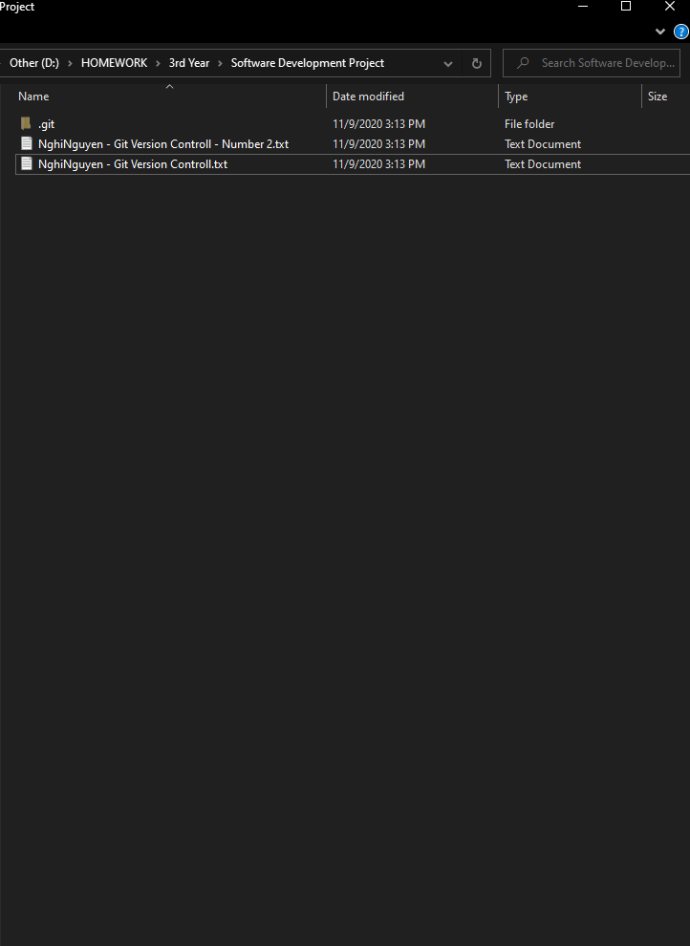

Everything seems to work properly, now let us switch back to the current situation where the latest files are up-to-date, after that do the **git commit** to merge everything to the master branch:

